1. 
2. 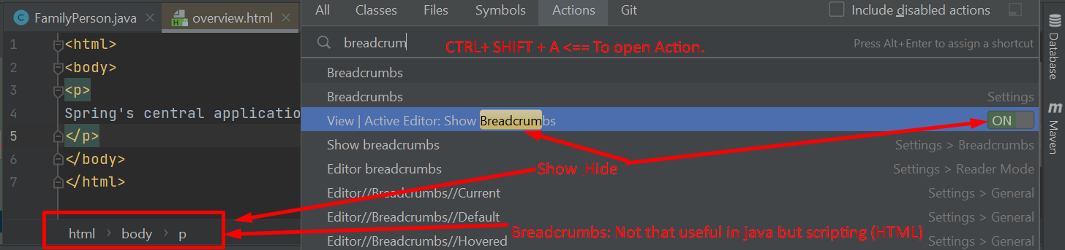
3. 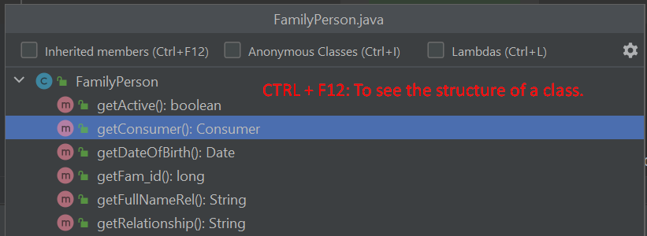
4. 
5. 
6. 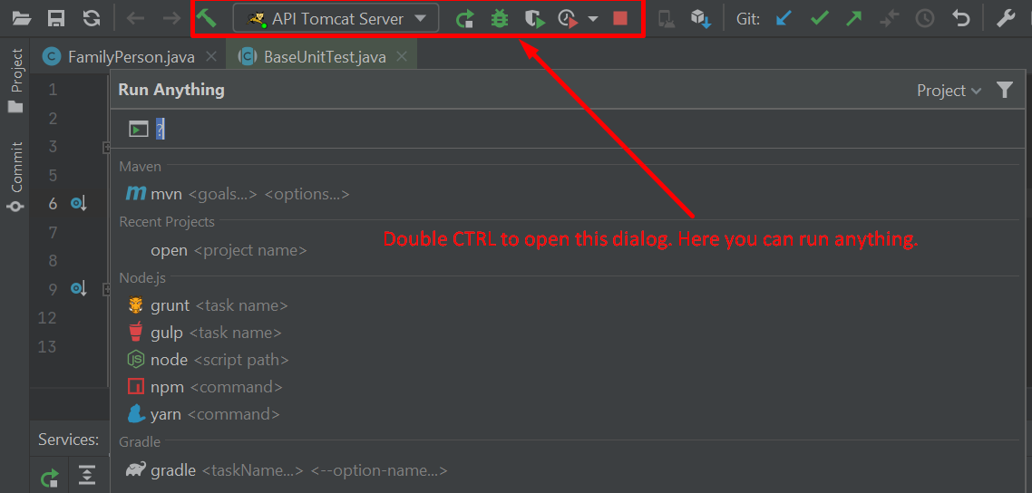
7. Command🡺 To hide or show all the windows except document window  
   